Command to login to aws using bash:

$ ssh -i DevOps-Demo.pem -v ubuntu@13.48.149.62

File Creation Task

**Create a directory called ""my_folder"", navigate into it, and create a file named ""my_file.txt"" with some text. Then, create another file named ""another_file.txt"" with some text. Concatenate the content of ""another_file.txt"" to ""my_file.txt"" and display the updated content. Finally, list all files and directories in the current directory.**

--------------------------------------------------------------------------------------------------------------------------------------

ubuntu@ip-172-31-37-228:~$ mkdir my_folder

ubuntu@ip-172-31-37-228:~$ cd my_folder/

ubuntu@ip-172-31-37-228:~/my_folder$ touch my_file.txt

ubuntu@ip-172-31-37-228:~/my_folder$ vi my_file.txt

ubuntu@ip-172-31-37-228:~/my_folder$ vi another_file.txt

ubuntu@ip-172-31-37-228:~/my_folder$ cat another_file.txt >> my_file.txt

ubuntu@ip-172-31-37-228:~/my_folder$ cat my_file.txt

This is a Demo Test file

First Task

This is a sample test file

ubuntu@ip-172-31-37-228:~/my_folder$ ls -ltr

total 8

-rw-rw-r-- 1 ubuntu ubuntu 31 Apr 14 14:19 another_file.txt

-rw-rw-r-- 1 ubuntu ubuntu 69 Apr 14 14:20 my_file.txt

--------------------------------------------------------------------------------------------------------------------------------------

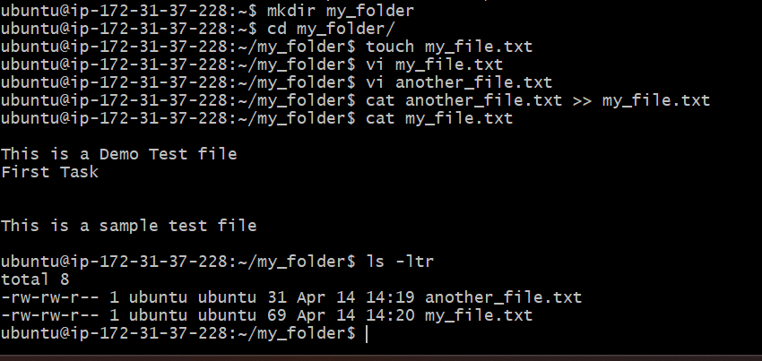

**Create 20 files with .txt extensions and rename the first 5 files to .yml extension and Print the latest created top 5 files among the total no of files".**

--------------------------------------------------------------------------------------------------------------------------------------

ubuntu@ip-172-31-37-228:~/my_folder$ vi change_file_name.sh

ubuntu@ip-172-31-37-228:~/my_folder$ chmod +x change_file_name.sh

ubuntu@ip-172-31-37-228:~/my_folder$ ./change_file_name.sh

ubuntu@ip-172-31-37-228:~/my_folder$ cat change_file_name.sh

for i in {1..5};

do

mv file$i.txt file$i.yml;

done

ubuntu@ip-172-31-37-228:~/my_folder$ ls -ltr *.yml

-rw-rw-r-- 1 ubuntu ubuntu 0 Apr 14 14:26 file1.yml

-rw-rw-r-- 1 ubuntu ubuntu 0 Apr 14 14:26 file2.yml

-rw-rw-r-- 1 ubuntu ubuntu 0 Apr 14 14:26 file3.yml

-rw-rw-r-- 1 ubuntu ubuntu 0 Apr 14 14:26 file4.yml

-rw-rw-r-- 1 ubuntu ubuntu 0 Apr 14 14:26 file5.yml

--------------------------------------------------------------------------------------------------------------------------------------

